Reception: Training Quiz

**Name: ______________________**

Please answer the questions below to the best of your ability with as much detail as possible.

This is just so we can see which areas you need further training in don’t worry if you don’t know the answer we will go over everything in detail.

# Answering calls

***Melissa Hesford from Monadelphous is calling to make an appointment for a new patient. He sprained his ankle while playing soccer over the weekend, on his R&R. Mel states she only requires a letter from the consult and not a certificate. Please detail the procedure below (3 Marks)***

This appointment is known as a: ___________________

1. _____________________________________________________________________________________________________________________________________________________________________________________________
2. _____________________________________________________________________________________________________________________________________________________________________________________________

***A patient is calling to make an appointment with a specialist, they have not been seen at REDiMED previously, referred from JHC, private patient, crush injury to hand last night. List the Information to give over the phone* *(3 Marks)***

1. _____________________________________________________________________________________________________________________________________________________________________________________________
2. _____________________________________________________________________________________________________________________________________________________________________________________________
3. _____________________________________________________________________________________________________________________________________________________________________________________________

# Booking Appointments

***Donna from Citic Pacific Mining is calling to book in a new patient with Dr Adrian Brooks for a lower back strain. Please detail the procedure below (2 Marks)***

1. _____________________________________________________________________________________________________________________________________________________________________________________________
2. _____________________________________________________________________________________________________________________________________________________________________________________________

# Checking in Patients

***Three patients are standing at Station 2 waiting to check in for their appointments. You are sitting at Station 3 and all other receptionists are on the phone you:*** *Circle the correct response (1 mark)*

1. Wait for the receptionist at Station 2 to finish their call and service the patients
2. Call them over to your desk and check them all in at once and put up their files
3. Call them over to your desk and check them in one at a time

# Sending Medical certificates/stickers

***Please circle the errors on these stickers and detail the procedure you would need to take to fix it.*** *(2 marks)*

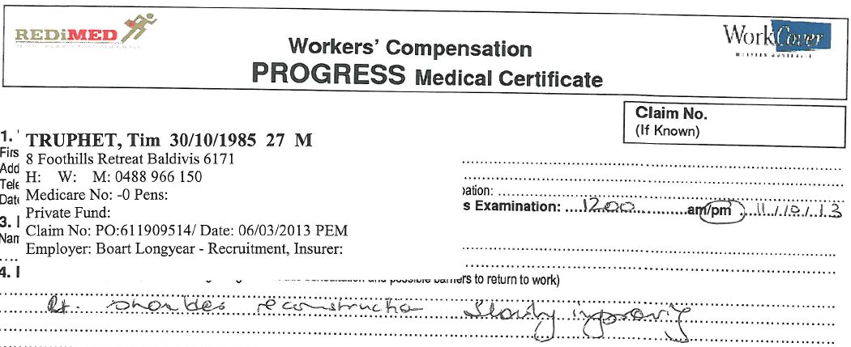

_____________________________________________________________________________________

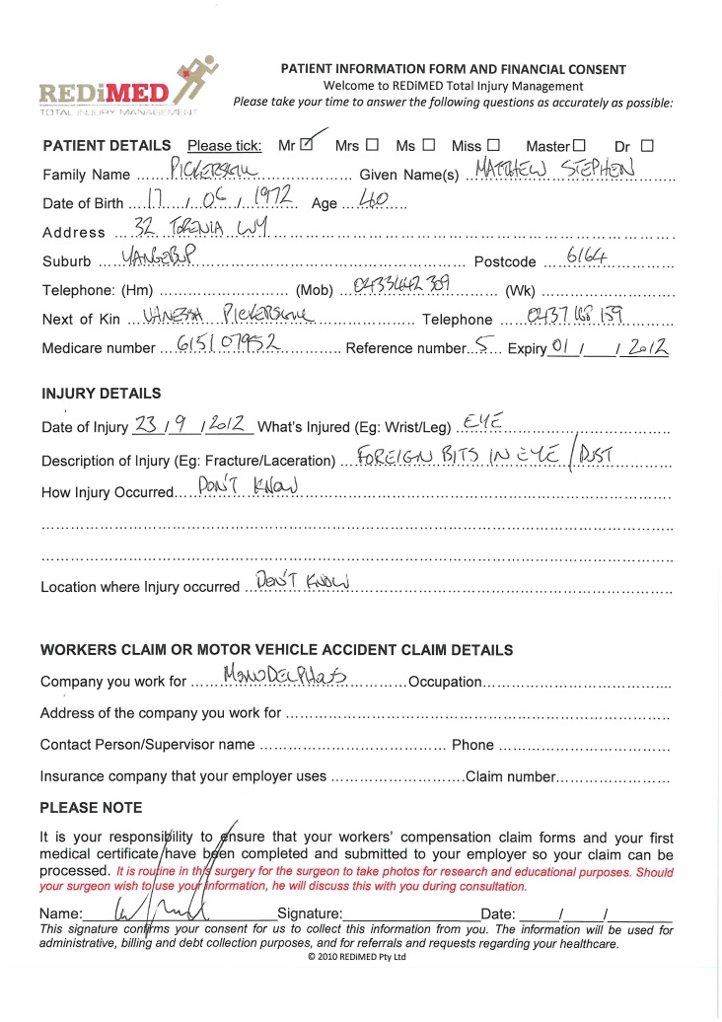_____________________________________________________________________________________

# Patient info forms

***Please circle the errors on the patient info form and what you would do to fix it. (3 marks)***

1. ______________________________________

____________________________________________

____________________________________________

____________________________________________

____________________________________________

____________________________________________

____________________________________________

# Private Billing

***Tim Darch brings you a patient that has seen both himself and Dr Daniel Luo for an initial consult. He tells you his code is a1. Please circle the correct response (1 Mark). For additional points circle the incorrect parts of the remaining two statements (4 marks).***

1. 104 for an initial consult is billed on Dr Luo’s appointment, there is no appointment in Genie for Tim so a1 also needs to be processed on the same invoice through the Redimed machine.
2. 105 for an initial consult is billed under Dr Luo and a1 is billed under Tim, if there is no appointment one is created. Dr Luo’s payment is processed under the 2hands machine and Tim’s is processed under the Redimed machine.
3. 104 for an initial consult is billed on Dr Luo’s appointment and put through the Redimed machine. A1 is billed on a separate invoice under Tim’s appointment through the 2hands machine.

## True or False?

***Please circle T or F to the statements below. (4 marks)***

|  |  |  |
| --- | --- | --- |
|  | True | False |
| 1. Tim, Debbie and Rachel are the only staff members whose billing falls under 2hands. |  |  |
| 1. It doesn’t matter the appointment date that you are billing under as long as it is under the correct doctors name. |  |  |
| 1. A dollar sign in front of a patients name - $ SINGH Atinder – does not require reception to do anything, this is for accounts to action. |  |  |